**Marine Mammal Injury Database – Biologist notes**

This guide is meant to provide the non-programmer with some guidelines on how to enter cases. The perspective is based upon entering entanglement cases; however, the basics apply to any data wishing to be entered.

It is important to realize that this section is meant as a supplemental piece to the entire database manual. Please review the entire manual before database use.

This database was designed to be used by NERO staff for ‘warehouse’ storage of all large whale human interaction (HI), strandings and mortalities. Information within the database is meant for NOAA staff only unless cleared by the appropriate NERO programs. Currently, a data request application is being vetted through the North Atlantic Right Whale Consortium board of directors for approval. If approved, the public may request approved information from the database (non-sensitive) through the consortium and receive their requested data in a spreadsheet format.

The database is currently stored on a NERO server maintained by IRM. Access to the database is only permitted for NOAA staff. Staff outside of the NERO may need VPN access through their computer for access. Contact NERO PRD staff first for access approval who will then guide you to NERO IRM for the appropriate access application forms.

Database Structure and Categories

Animal - The Animal is the foundation of the database structure with all fields being linked to a particular Animal. For Animals the user can add additional cases, information or attached files using their unique ID names or numbers. All animals regardless if an ID name or number is assigned for that individual Animal, will have a unique sequentially generated ID number will be generated. This allows non-ID’d Animals to also be unique and reduces conflicts for database summaries and reports. For example, if all minke whale cases were not given a computer generated ID number automatically any search involving minke whales would indicate only one animal involved with all Human Interaction cases.

Cases – Cases are defined generally as HI, stranding or mortalities for one animal. Cases follow the unique Animal and accordingly multiple cases can be assigned to the same individual Animal. There also can be multiple cases for the same ‘event’. For example, a deceased whale with recent ship strike trauma and entangling gear present, would have two cases for the same ‘event’ – entanglement and ship strike. NERO PRD staff will fill in the corresponding cases to their duties. Another example would be if a dead, entangled carcass was found. There would be two cases for this animal. One would be the general stranding/mortality case which stranding program staff would fill out. The other would be an entanglement case filled out by entanglement staff. If two or more animal are involved with an entanglement incident then each animal receives its own case. Multiple animals stranding are handled differently and consult with the NERO stranding group for proper protocol. There are three types of cases: Entanglement, ship strike, or case (generic stranding/mortality case).

Observations – Observations are the individual sightings by human which make up a case within one calendar day. Generally, there is only one observation per day/per case with the ‘status’ (alive/dead, entangled, gear shed, etc) indicating how the animal was at the end of the observation (end of the day). For example, if an entangled whale was sighted early in the morning and was lost for 6 hours, then found later in the same day the database would include information from both of those sightings (usually explained within the narrative). If the animal is observed through midnight, then two observations would occur. Animals that are tracked with telemetry are not given an observation for every day they are tagged. Only when the animal is sighted by a person is an observation created. Telemetry tracks and information can be added in the attached files section for the animal or case.

Gear identification – Generally, has restricted access due to sensitive nature. NERO (potentially other regions in the future) gear experts will fill in this information that is associated with a particular case. Release of this information with contacting appropriate NERO gear expert staff is prohibited. *Visibility and access to these fields are only granted to users with this specific permission.*

Serious Injury (SI) determination – NEFSC will be using the database to help them determine large whale SI status for HI cases. NEFSC will exclusively fill out these fields that are associated with a case. Release of this information without contacting appropriate NEFSC staff is prohibited.

Fields – Fields are specific data within the database. Think of fields as a column in a spreadsheet. Certain fields may only be visible, depending on permission and/or the type of case you are entering. For example, you may not see all ship strike fields if you are entering in an entanglement case. However, a large number of fields are used by all cases. Any blank fields not entered are automatically assigned an unknown value. In other words, there won’t be any blank fields in existing cases.

Website navigation

The website/database is located at: <https://www.nero.noaa.gov/ci/>

Prior to accessing the complete database you will need to contact Jamison Smith or David Morin at NERO for a username and password. Please do not release your username and password for other staff to use. Every addition, modification, or deletion is associated with the logged in user.

Login page (Photo 1) – Enter your specific username and password for the database and press the login button below the password entry area.

*Photo 1*

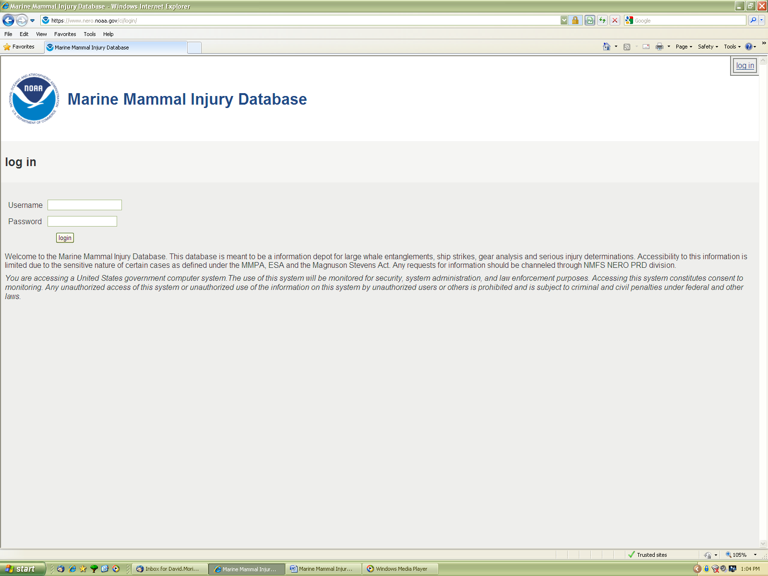

Entry page (Photo 2) – This page allows the user to begin searching for specific animal or cases as defined by the search fields in the boxed section of the page (green arrow) or other searches such as the tabbed links above the boxed section, such as the yearly summaries (red arrow). Next to the red arrowed tabs are some administrative tools (only visible to administrators) for managing the database. Users may also begin to add animals or cases under the appropriate tabs (ex. adding a new case, click on the “add” link just below “cases”). The search functions under the tabs have more extensive features than the boxed search features on this page.

*Photo 2*

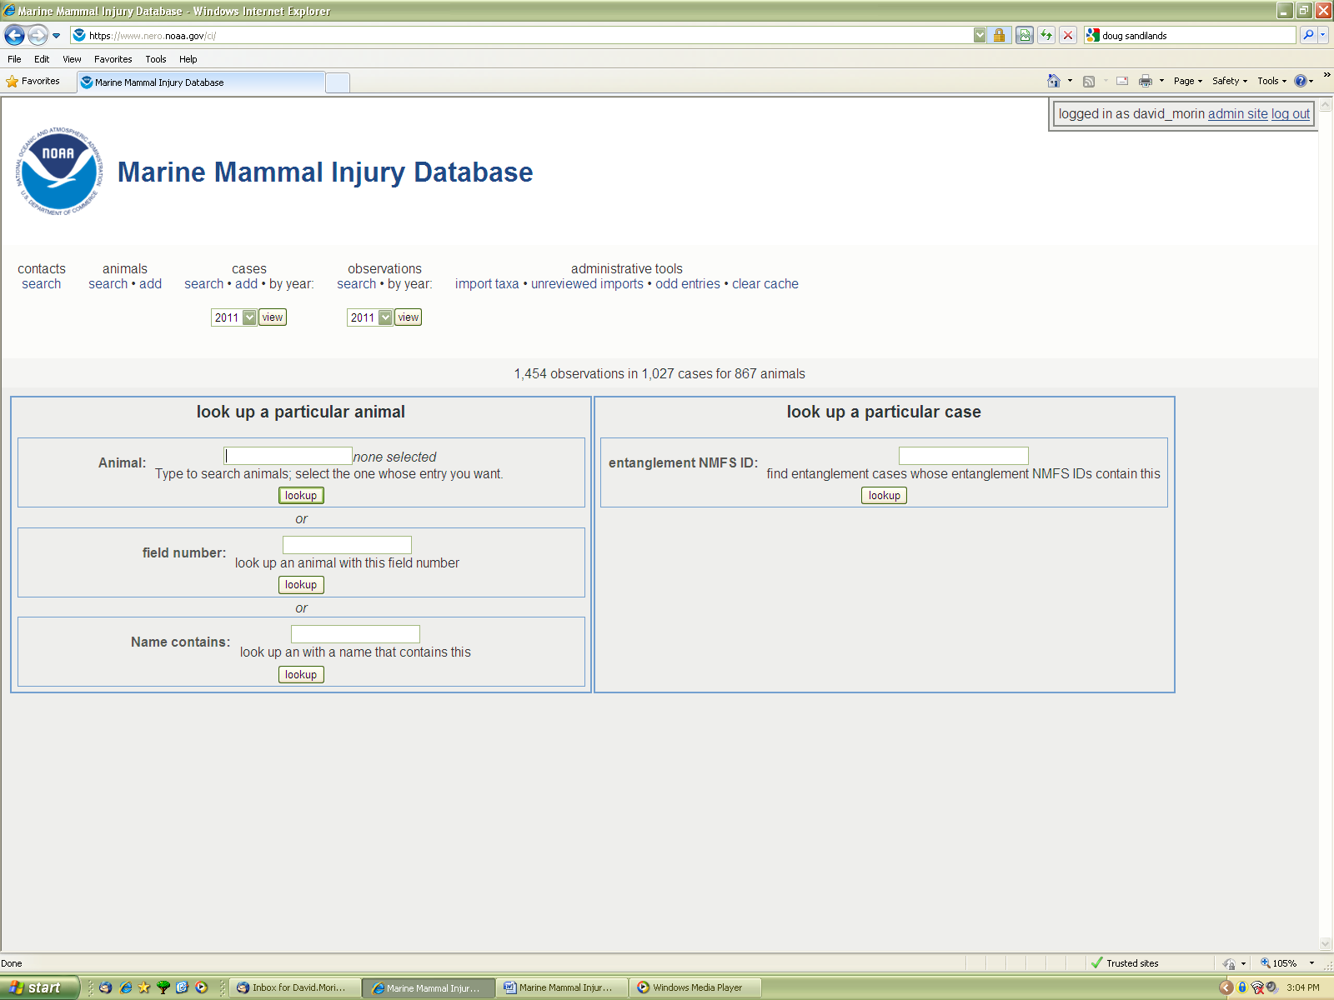

We will start with the assumption that the user is adding a new case. Searching for specific animals or cases will be covered later in this section.

New case (Photo 3) – After clicking the “add” under cases, it will bring you to the new case page. There are two radio buttons labeled “add a new animal entry” and the highlighted one “use an existing entry”. If you have a known ID’d animal for your entry case, you should begin my typing the name or ID number (not case sensitive) in the “existing animal” box. You will see as you type the database will automatically begin to narrow down choices depending on the characters you type. For example, if you type “Canopy”, you will see the humpback whales: Canopy and 2011 calf of Canopy appear in the list below. So depending on the characters you type, the database will return any animals that contain those characters. This allows you to check to see if the animal already exists in the database. If you have a new animal, the ID search turned up negative or it is an unknown/not ID’d animal (ex. minkes), then click on the new animal entry button. This will create a brand new animal for the database. Don’t worry if you cannot initially find an existing animal but discover it later. There is a merge feature that will allow you to merge animals, cases or observations. The merge feature will be discussed later.

Below the “Existing animal” box is the “Case type” drop down menu. In this menu you can pick the type of case that you would like to enter: Entanglement, ship strike, or case (generic stranding/mortality case). Hit the “Submit” button after your existing/new animal, and case type are chosen. In this subsequent case explanation we will ‘enter’ a new entanglement case for a new animal.

*Photo 3*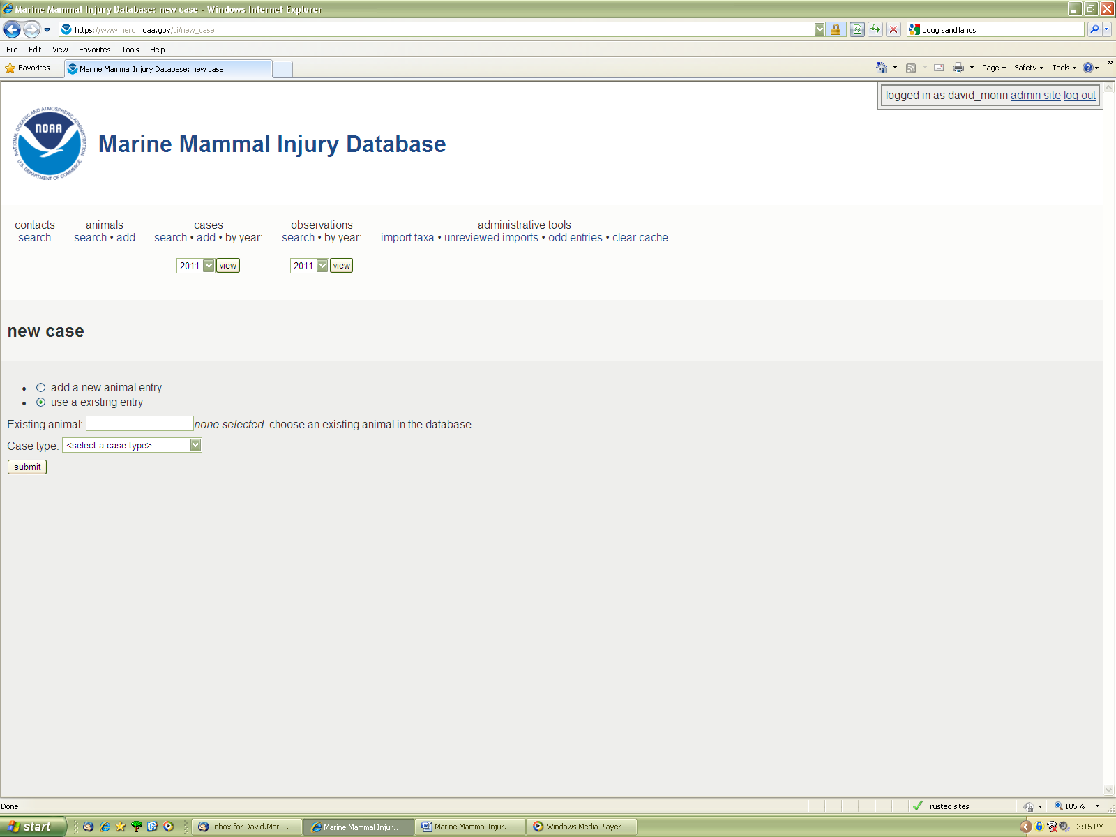

New Case entry page: the ‘tabbed’ page (Photo 4) – After submitting for a new case it will bring you to this page. The tabs below are meant to be entered from left to right. Depending on who entered/edited the last case, the leftmost tab “Animal” may not be highlighted. Click on the “Animal” tab which will show the page below. The reasoning behind why the “Animal” tab is not highlighted automatically is in case the user needs to edit a number of specific fields in existing cases. The database has a memory of which last tab was used.

Tabs can be navigated by clicking on the next tab near the bottom of the page or the appropriate tab you would like to enter in information. For most users, I would highly suggest you navigate the tabs in order from left to right. Do not skip tabs. There is a large amount of fields and while you may think you don’t have the necessary information for some fields, 99% of the time you do have enough for at least on field on each tab.

Most fields have visible definitions next to the entry box. Please read and understand these definitions before entry. If you have any questions as to the definition of the field, please contact appropriate NERO staff beforehand.

The “Animal” tab is section where the user will create the new animal for the new case. Focusing on entanglement – our first entry will be in the name field if it is a known/ID’d animal that is new to the database. Generally, you don’t need to add symbols to the name field (ex. for a right whale just enter 2427, not #2427). If the animal is truly an unknown, just leave the field blank. The database will automatically assign a unique ID number for that animal regardless if known or not.

“Determined taxon” this is an auto-generating taxon list. Simply type in the common or scientific name of the species and it will give you options to choose. Remember that this field is for confirmed species ID. If it is unclear as to the exact species, choose an order, suborder or appropriate taxa on the tree.

The next field is the “Determined sex” field. Pretty self explanatory. If unknown leave blank.

The next possible field is “Dead on or before”. Obviously, only needed for deceased animal cases. Database definition: A date when the animal was certainly dead, as determined from the observations of this animal. If you're unsure of an exact date, just put something certainly after it; e.g. if you know it was dead sometime in July of 2008, just put 2008-07-31 (or 2008-08-01). If you're totally unsure, just put the current date. Any animal with a date before today is considered currently dead.

The rest of the fields are for the stranding crew.

*Photo 4*

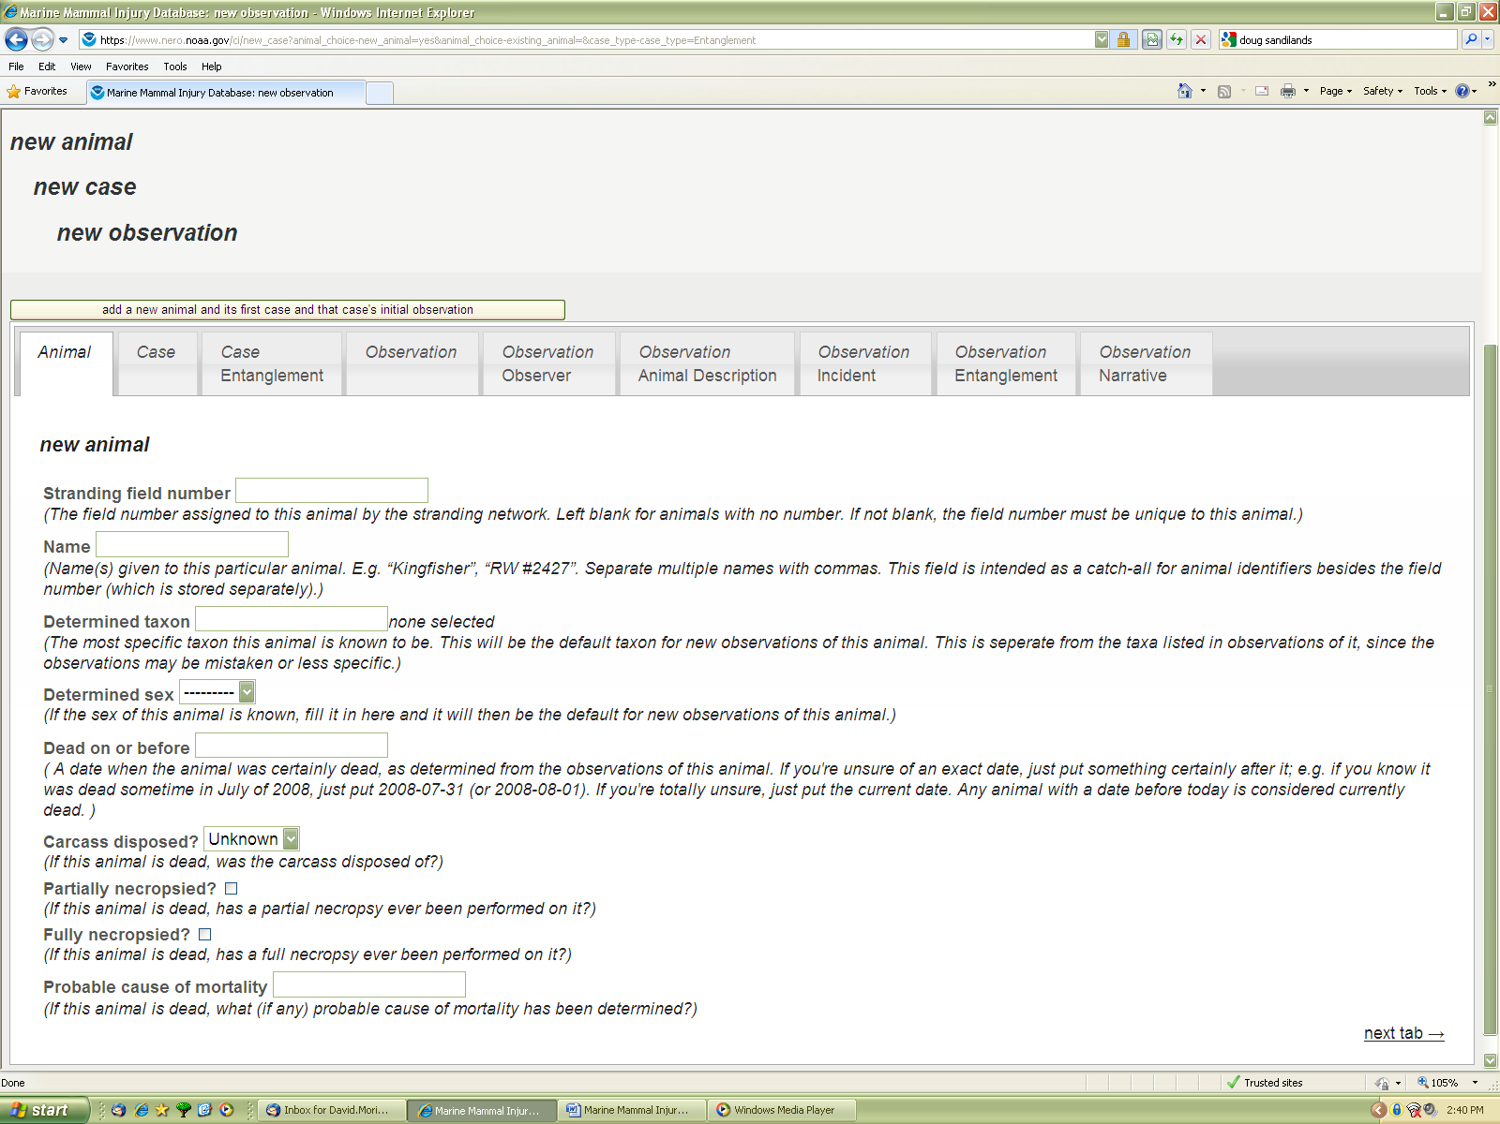

Case tab (photo 5) – The case tab is the beginning of how NOAA tracks a case.

The “incident was on or after” field deals with known animals and when their last gear free sighting occurred. This allows users to know when the event could have occurred and how long it was entangled before its first entangled sighting. This is helpful for health and gear analysis. You can use PCCS for humpbacks and the right whale consortium for right whales.

“Validity” field has three choices – confirmed, suspected or invalid. A confirmed entanglement case must be an animal with gear present that was either documented (entanglement is visible in documentation) or witnessed by a reliable observer (trained network member, fisherman with experience, etc.). Recreational and even commercial fisherman, USCG and other marine professionals cannot be relied upon to always make an accurate assessment if the whale is entangled. If the case is unclear, then lean towards a conservative assessment. Think if the evidence would stand up in court. If you feel the case cannot be a confirmed entanglement, then you can choose the suspected field. Invalid cases are existing cases that were later determined not be an actual case. It is important to note, live or dead animals, that have new entanglement trauma but no gear present are NOT considered an entanglement case. This definition is different than in the past and accordingly summary numbers have changed for past years. The old, now “invalid” cases, still exist in the database and can be found but they would not count towards new summary numbers. NEFSC and the NERO stranding program will cover these cases.

“OLE investigation” - yes, no or unknown. Certain cases might be under investigation by OLE, usually for suspected illegal gear. By answering this field with a yes, it will provide a highlighted red warning for this case, notifying the user that any information on this case should not be released until the investigation is complete.

“Human interaction” – yes, no or unknown. A carryover from the stranding portion of the database. If you are entering in a known entanglement case then naturally this will be “yes”.

*Photo 5*

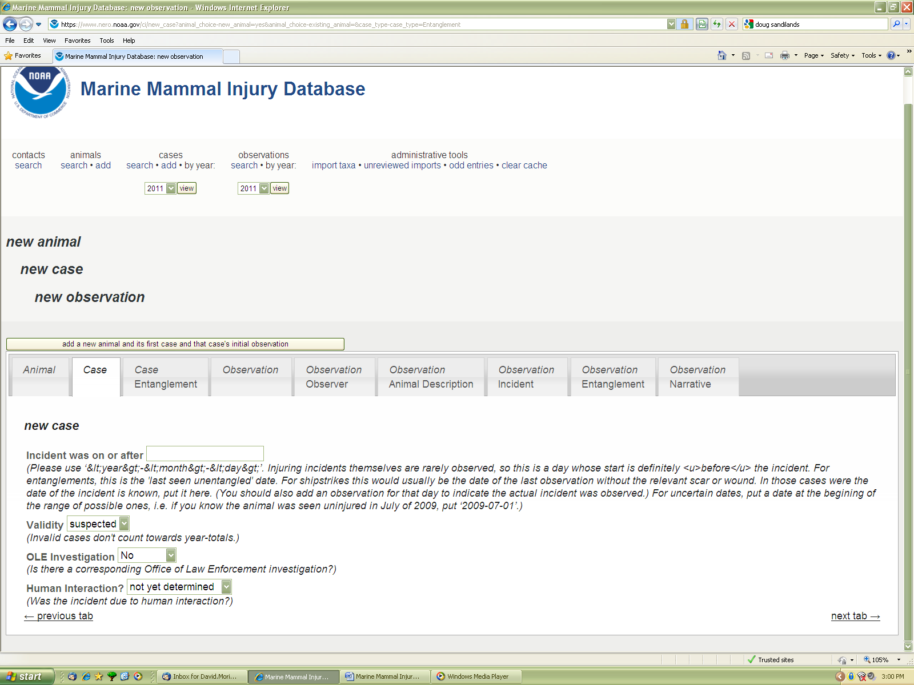

Case Entanglement tab (Photo 6)

“Entanglement NMDS ID” field - This allows users to enter in the NMFS ‘E code’ (ex. E01-11 – the first known case for 2011). You can also put in other NMFS or historical codes in here and the case will be found with any of the appropriate codes. In other words if case E01-01 was also known as E03-01 (for example, because of the new entanglement definition where gear must be present for a case, this has changed some historical classifications); I would enter “E01-01 (formerly known as E03-01)” So if a user is searching for the case regardless if they have a new or old report they will find the appropriate case. The “formerly known” is added so the user is not confused with just two ‘E’ numbers listed.

The database also stores any old NMFS ID numbers ever entered in this field. In other words if the user made an error or correction after the initial entry, the old number is still associated with this case even though it is not visible. This old number is also used in a search. For example, say the user entered E32-11 by accident and saved the entry. They then realized their mistake and edited the case, ‘deleted’ the incorrect ‘E’ number of E32-11, and then entered the correct ‘E’ number E33-11, then saved. If a search was conducted for E32-11, at the minimum, this new E33-11 case and the ‘true’ E32-11 will come up in the search. The user will then have to determine the correct case by using other fields such as species, name, observation date, etc. Again, the reasoning behind this is changes often occur and the database was designed to be all inclusive and let the user determine the correct case.

“Was the gear analyzed” field – yes, no or unknown. NEFSC gear experts usually fill out this field although for historical cases this can be entered by entanglement experts who have knowledge about the case.

*Photo 6*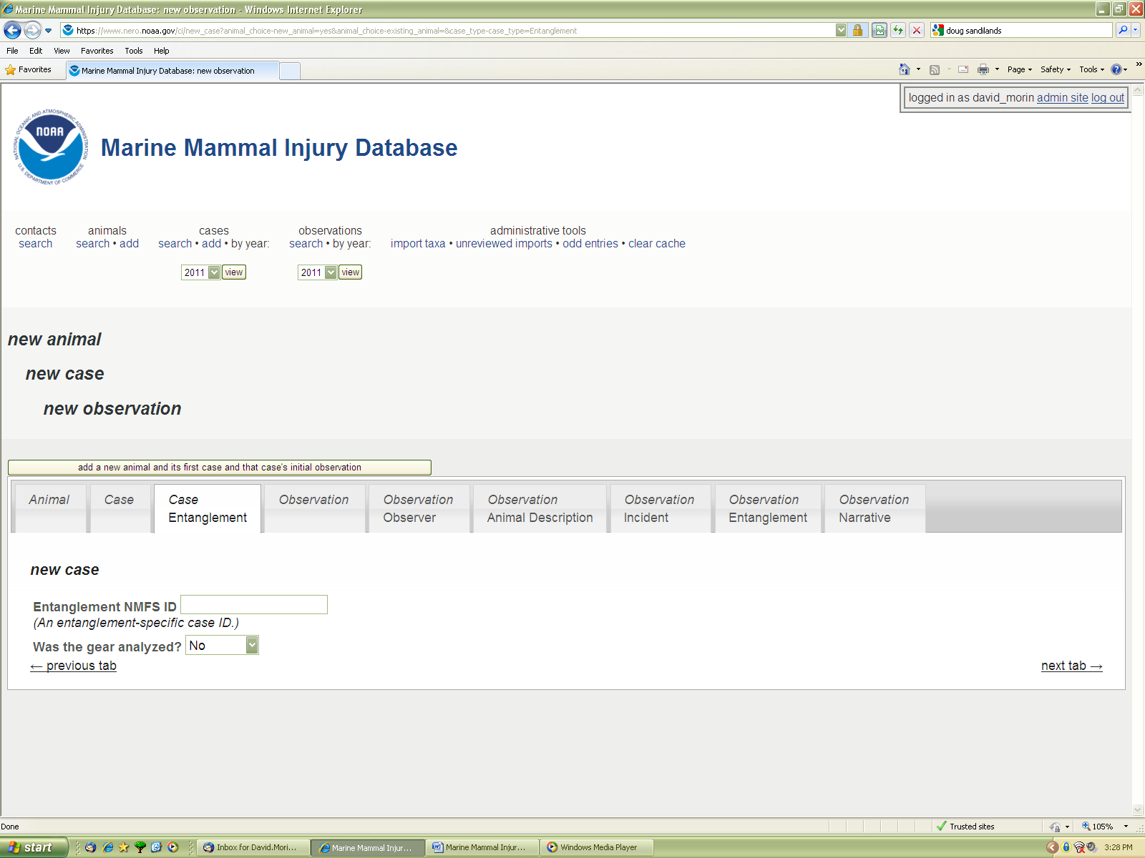

The next six tabs correspond to the observation (the events of one observation day) for this new case.

“Observation” tab (Photo 7) – This is the reporting year, month, day and time of a network member reporting to NMFS. This must be the time and person that informed NMFS and not another network member. This may not be the actual person who witnessed the entanglement. For example, a fisherman could contact the USCG, who contacted NMFS. The USCG report time would go here. Often dates, times and reporters are different than the actual observers. Use military time.

“Reporter” field – The database keeps track of parties involved in cases. “No contact info for reporter” is self explanatory. If you know the reporter, you should select “Use an existing contact” button first. You will see a dropdown list of already used contacts. Generally, try to avoid potentially sensitive individual names and use the categories or organization names. For example, commercial fisherman, recreational fisherman, USCG, GA DNR Aerial Survey, etc. Whale watch companies all start with a WW. Again if you make a mistake and add a ‘new’ contact for one that already exists and you save the case, you can always merge the contacts later.

*Photo 7*

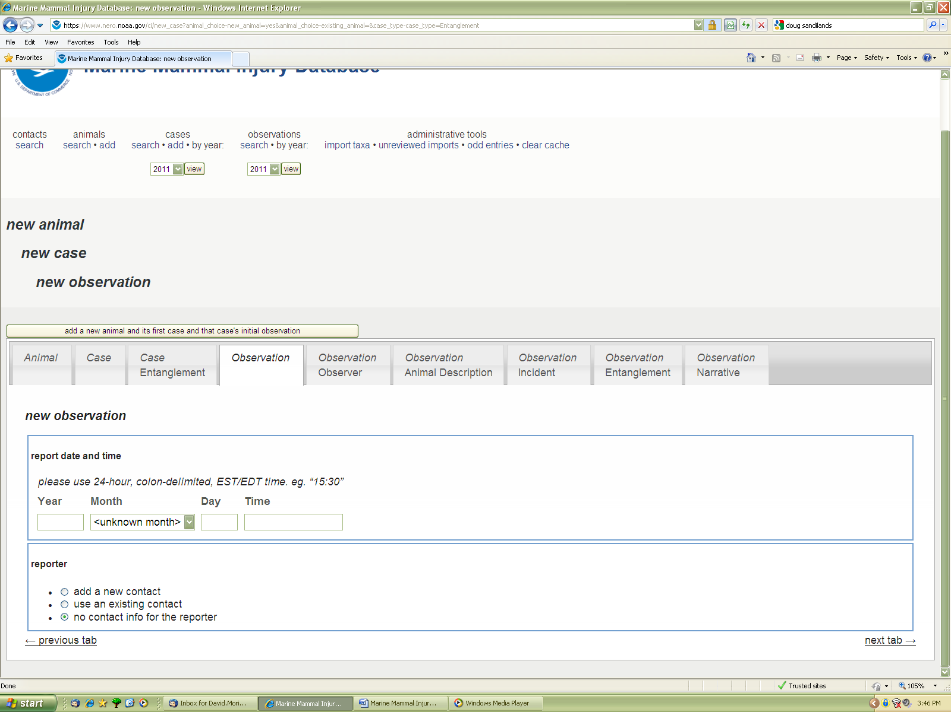

If you need to “Add a new contact” the page will expand (Photo 8). This allows you to enter in a new contact and appropriate contact information. The Contact affiliations is an early database leftover (may possibly delete it) that allows the user to lump a contact into one or numerous categories. If you would like to add a new category there are fields on the far right.

*Photo 8*

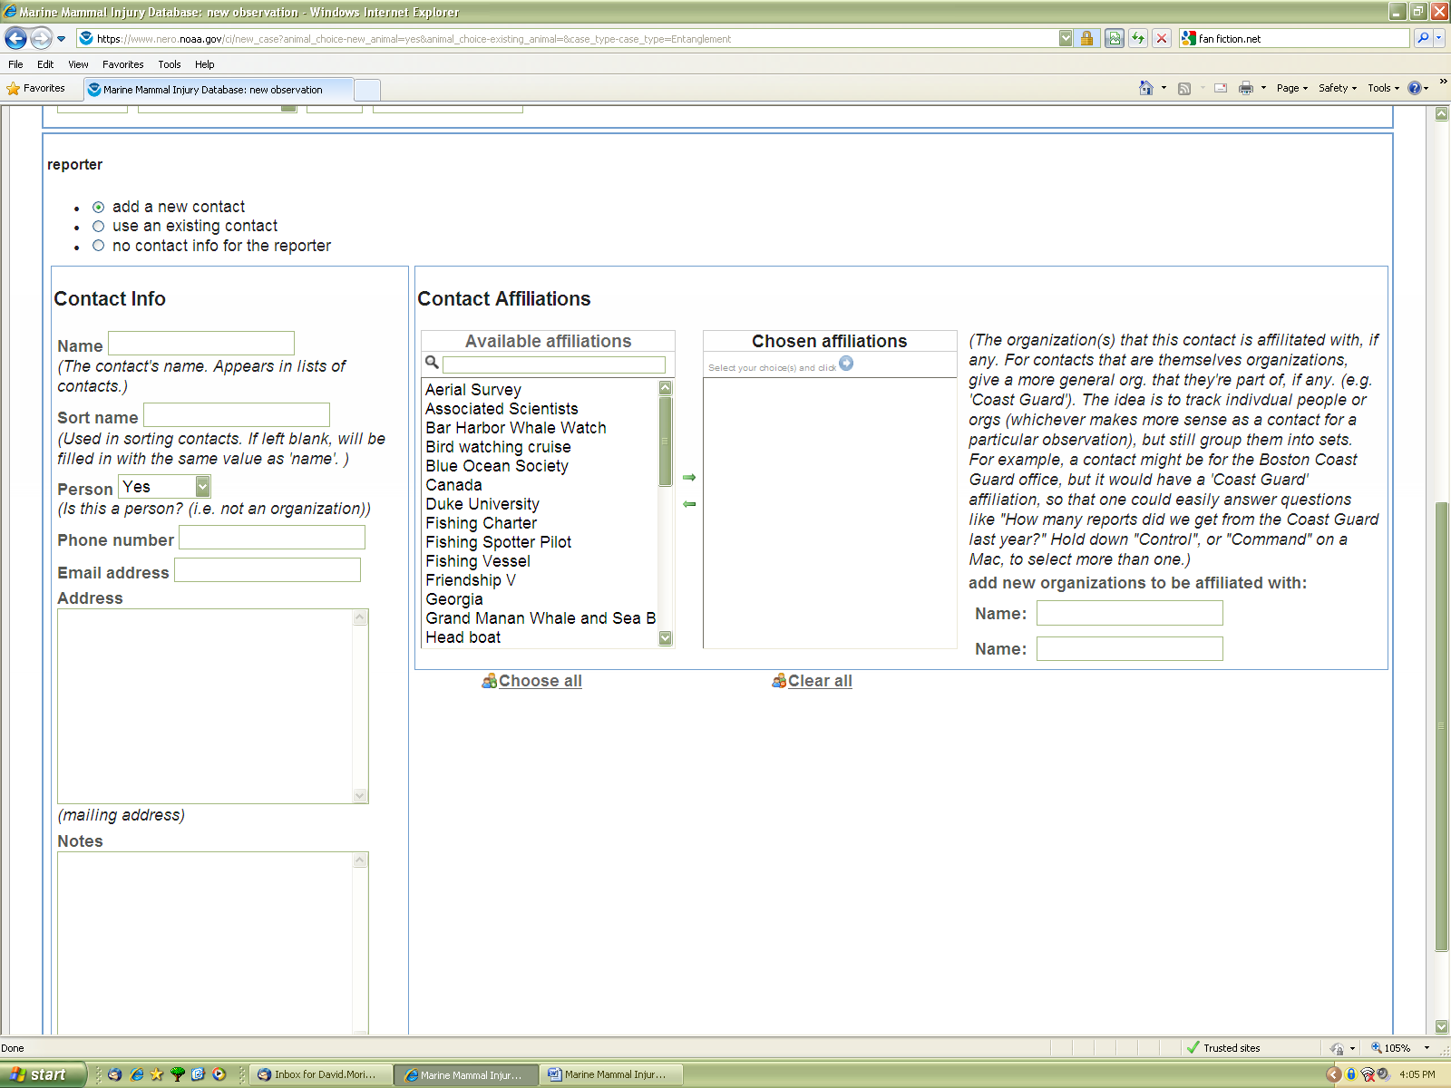

Observation Observer tab (Photo 9) – This tab has the same time, date and personnel fields as the last tab; however, this is the location that you put the information for who and when the witness actually observed the entanglement.

Below is the location of the first sighting of the entanglement. Remember to put the first location and time of the first sighting of the day. Do not put the last. The “observation location” field is a place to put a general description of the location (ex. 2.5 NM NW of Race Point, Provincetown, MA).

*Photo 9*

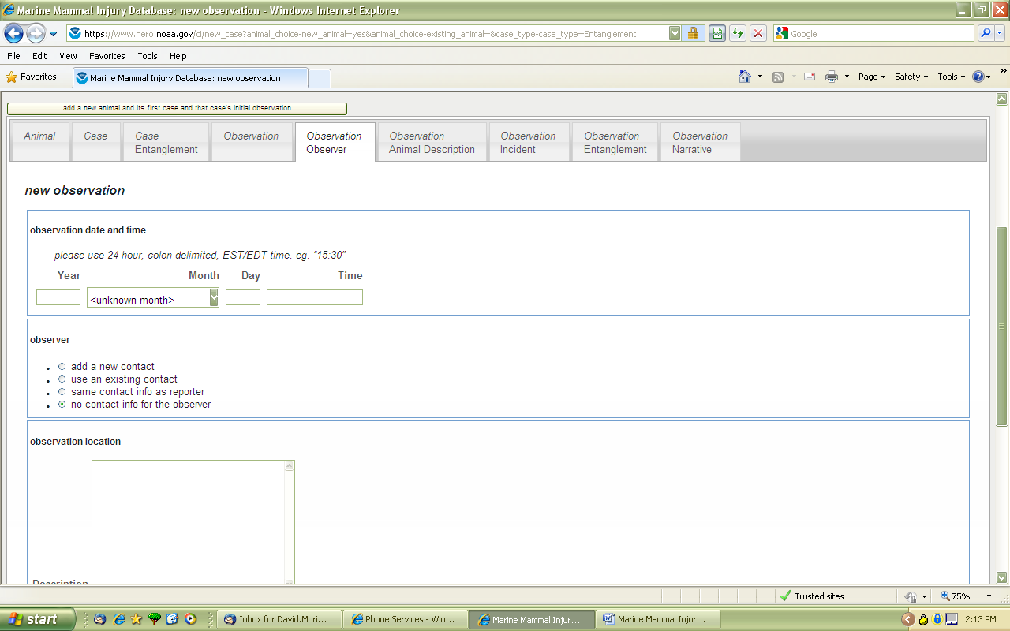

Photo 10 is the same tab as Photo 9. There are some buttons to put the country. A pull down member for what kind of waters (state, federal, etc.). Latitude and Longitude fields. Notice that you can enter the lat/lon in a number of different formats and it will automatically convert. Below that is a check box if the observer was on a vessel (carryover from ship strike information). Here you can put the name of the observer vessel, home port and a few other bits of information if available.

*Photo 10*

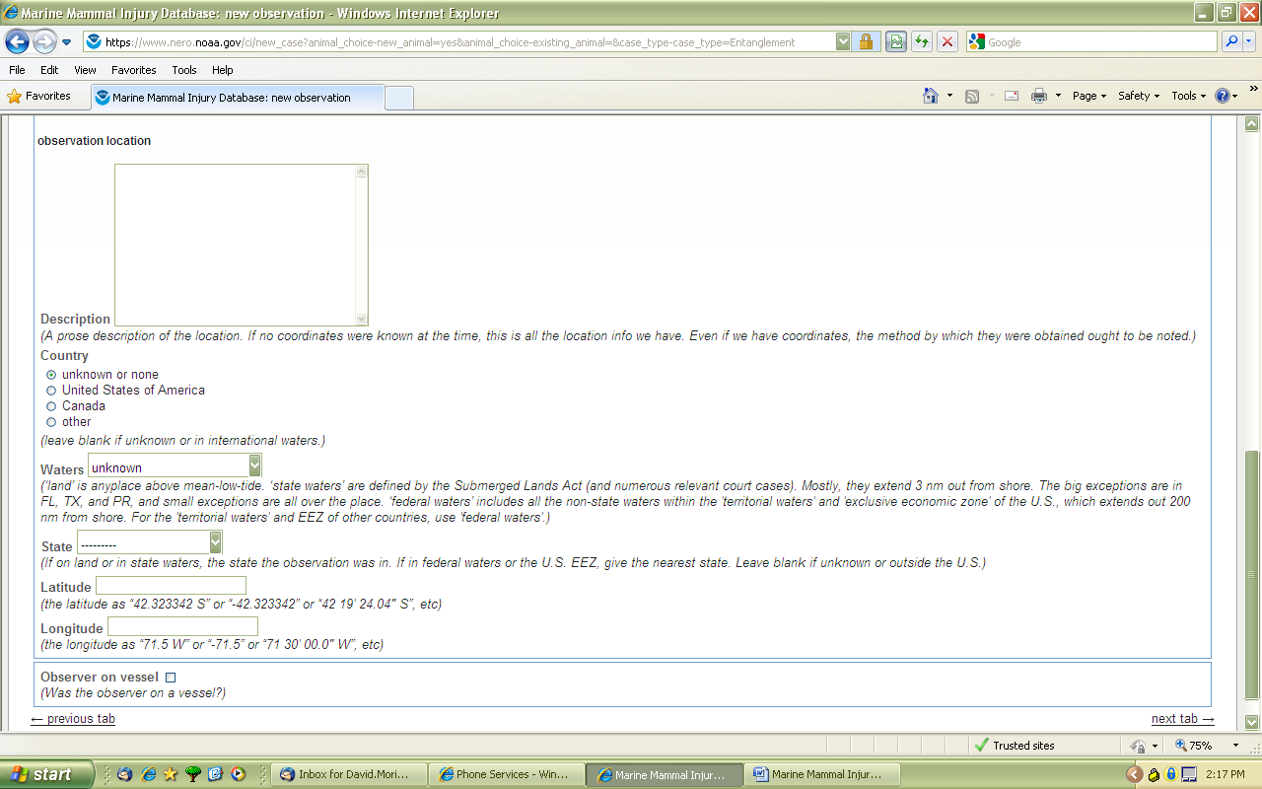

Animal description tab (photo 11) – There is a taxon field for the observation. What the animal was reported as, unconfirmed, correct or not. This could be different than the actual species confirmation ID under the “Animal” tab. Sex, if known, as described in the field. This again could be different than the confirmed sex field under the “Animal” tab. The “Animal description” field is a text field that allows the user to describe the animal if species ID was unclear or unconfirmed in the field. Be as descriptive as possible.

The “Animal length” field is a place to put the estimated or known length of the animal, in varying units. The auto or selected accuracy feature allows the user to show how precise the measurement was. For example, if you know the carcass was 10.075 meters and select auto, it will save the measurement as 10.075. However, if you select a number it will only save that number of decimal places. So in this case, if you selected 2 it would change the measurement to 10.08. Generally, you want to enter in the precise measurement and press auto. The exception is 10.750 or something similar that ends in zero. Auto will save it as 10.75; however, you know your measurement is more accurate so select 3 in this case.

“Age class” can be a subjective estimate at the time of observation. Remember for a very long case this classification may change over time. For example, the animal may start off as a calf, juvenile to adult.

*Photo 11*

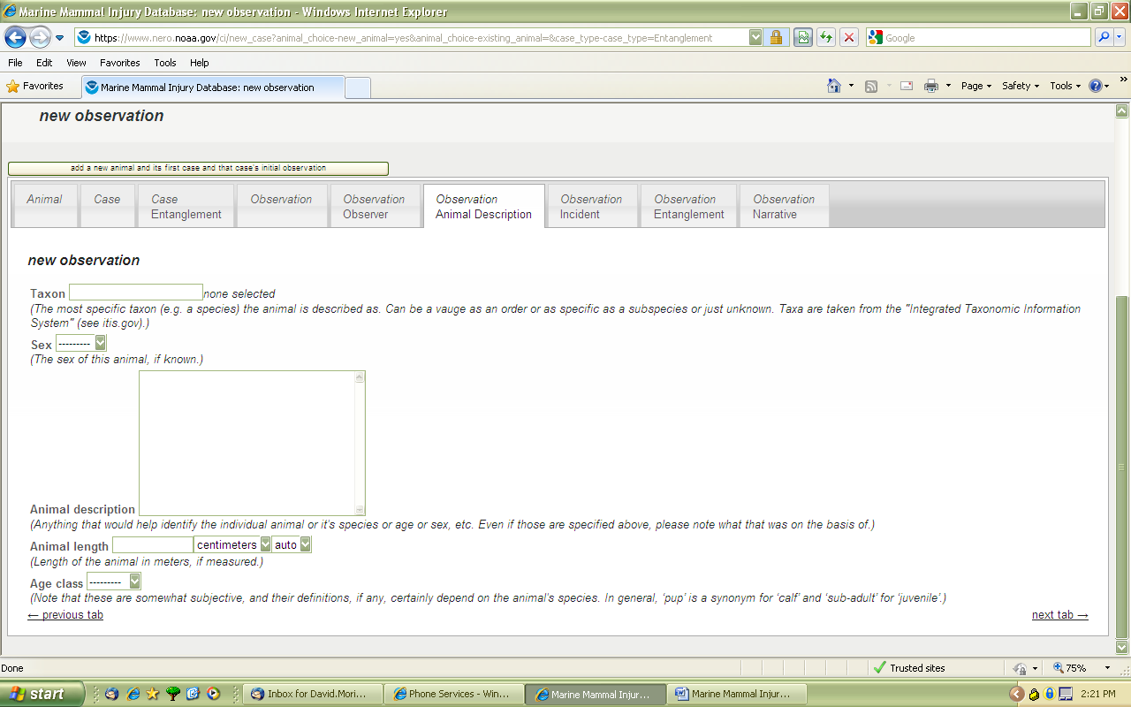

Observation Incident tab (Photo 12) – A large number of basic yes/no/unknown fields pertaining to the case. The “Body condition and wounds description” is the place where the user should describe any witnessed/documented wounds and the overall health of the animal. The biopsy and genetic samples taken are essentially the same thing except we are using the biopsy field as a core (dart) sample taken from a live animal at sea. “Was a tag put on the animal” includes any tag that was put on the animal during this observation AND if the animal already had a tag before the observation took place. For example, a disentanglement attempt on an already tagged whale would have this field as “yes”, even though a tag wasn’t added during this observation.

*Photo 12*

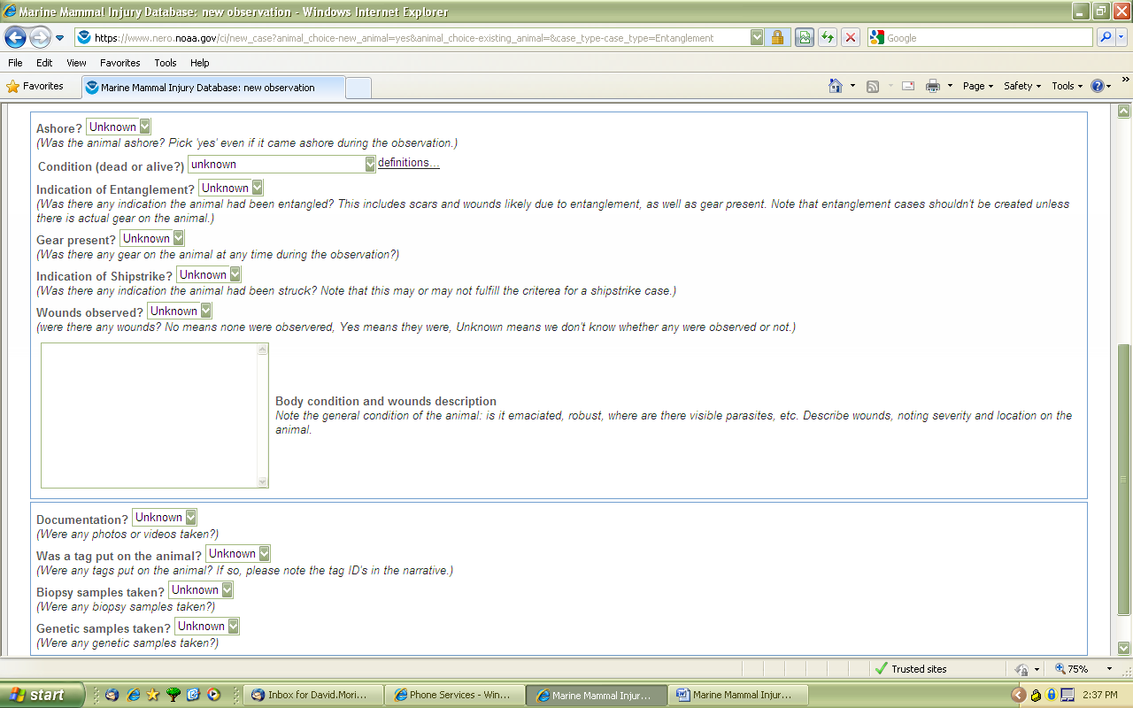

“Observation Entanglement” tab (Photo 13) – This tab contains information on how the whale was entangled. Anchored, entangled body locations, gear description and entanglement description. Pay attention to the definitions and follow those guidelines. The gear description is just focused on the gear, not how the whale was entangled, which is the entanglement description. There is also gear retrieved and by whom and disentanglement attempted. In other words would a take be considered under the permit. The entanglement status is the status of the animal at the end of the observation day. It is important to note that the only entanglement observations that do not involve gear present on the whale are gear shed observations.

*Photo 13*

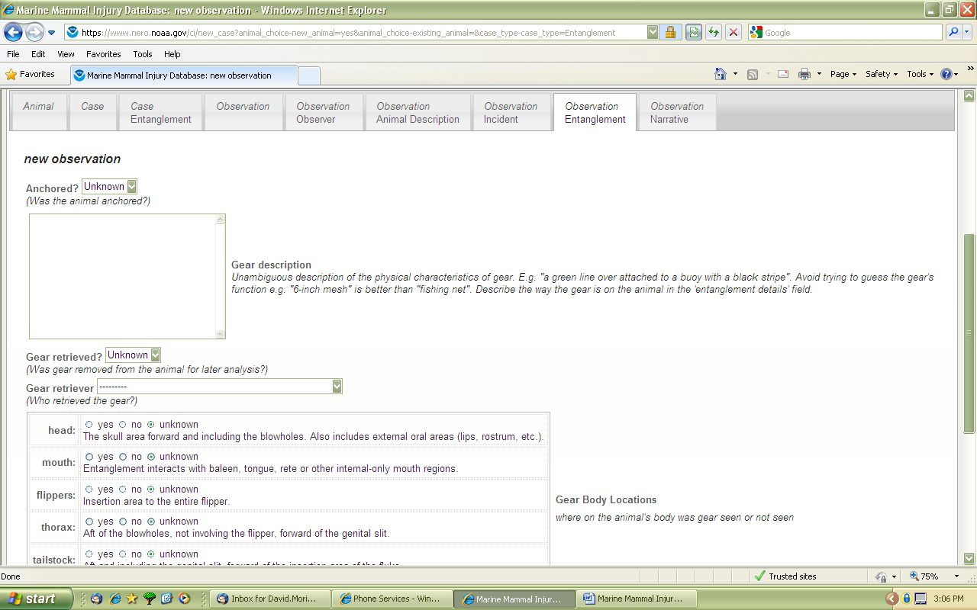

“Observation narrative” tab (Photo 14) – This tab is an extensive word summary of the entire observation. It is also useful to put notes/comments of the animal/case between observations here. This will allow for the most complete picture of the entire case. Please give appropriate credit of quotes and sources. You will frequently see “From PCCS website” for a narrative description of the observation. PCCS has worked extensively providing detailed accounts of the event, with little need to expand. Until NERO activates their ALWDN website, the PCCS website should continue to be quoted and used here. Feel free to add any additional comments you think are important to the case/observation. This field is searchable.

*Photo 14*

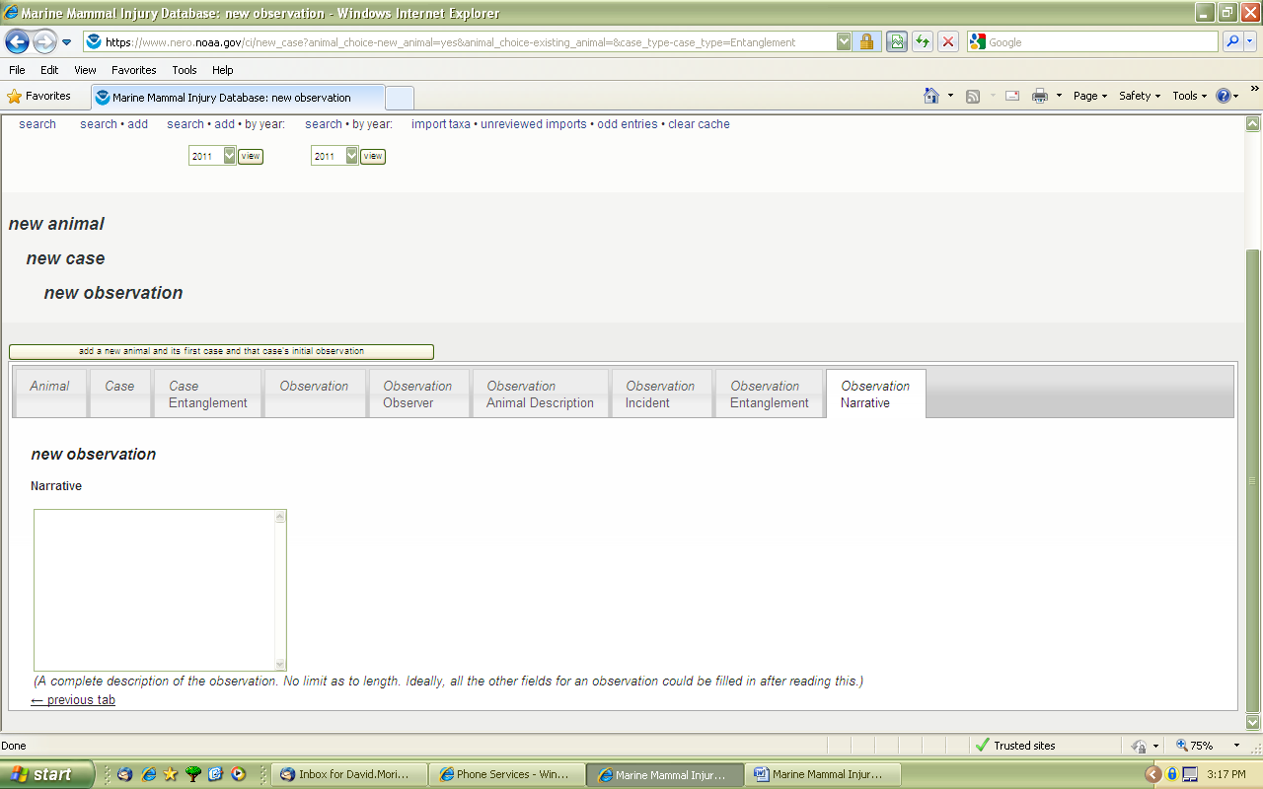

Merging animal, cases and observations

Users may incorrectly add a new case or animal into the database, warranting a correction. The database has an extensive merging feature that allows users to compare each field entry side by side. When merging it is important to remember the structure of the database: animal followed by case and then the observations. For example, if the user incorrectly creates a new animal and case for an already existing animal and case, they user must merge the animal first. After the animal is merged, you will then see the two corresponding cases under the same animal. If applicable, the user then merges the cases and then if necessary the observations. It is important to remember the first animal/case/observation picked is the one the information will be merged into.

The merge links are just above the tabs on any animal, case and observation page. When starting to merge an animal, if known, pick the animal you want to merge the information into and then search in the “other animal” field that appears. This field will auto-populate possible animals as you type and name or ID number. If the animal does not have a name or ID number, then you will need to use the auto-generated computer ID#. This number is listed when you do a search and see the animal/case.

Once the merging animal is chosen, then a page will appear with the original animal on the left and the animal to be merged on the right(Photo 15). Fields that are different will be highlighted in yellow. The central column is what the field entries will be after the merger is saved.

Search capabilities

There are a number of basic search functions on the home page and just above the tabs (referred to as titles from now on) that allow users to search for animal or cases based on common requests such as year, NMFS entanglement ID or animal ID. By design, the search features are all inclusive, including previously entered fields that have been changed. The reasoning is the user might not have the latest report and proper data to find the case. Ultimately, the search will provide a list of animals/cases/observations that fill all the current and past search criteria. More complex searches are found under the animal, case and observation titles

The overall database structure is important to remember when selecting a complex search and understanding the results. Generally, most management questions involve a case request and the user should start first with a case search. If details from the animal or observation are needed to further refine the search the appropriate boxes can be checked to expand those sections and see the corresponding fields.

Given the large number of fields in the database, which are all searchable, it is imperative the user understands the exact request. Given the complexity, if you are having trouble initiating a search or understand your results, please contact appropriate NERO staff who can guide you through your request.

*Photo 15*

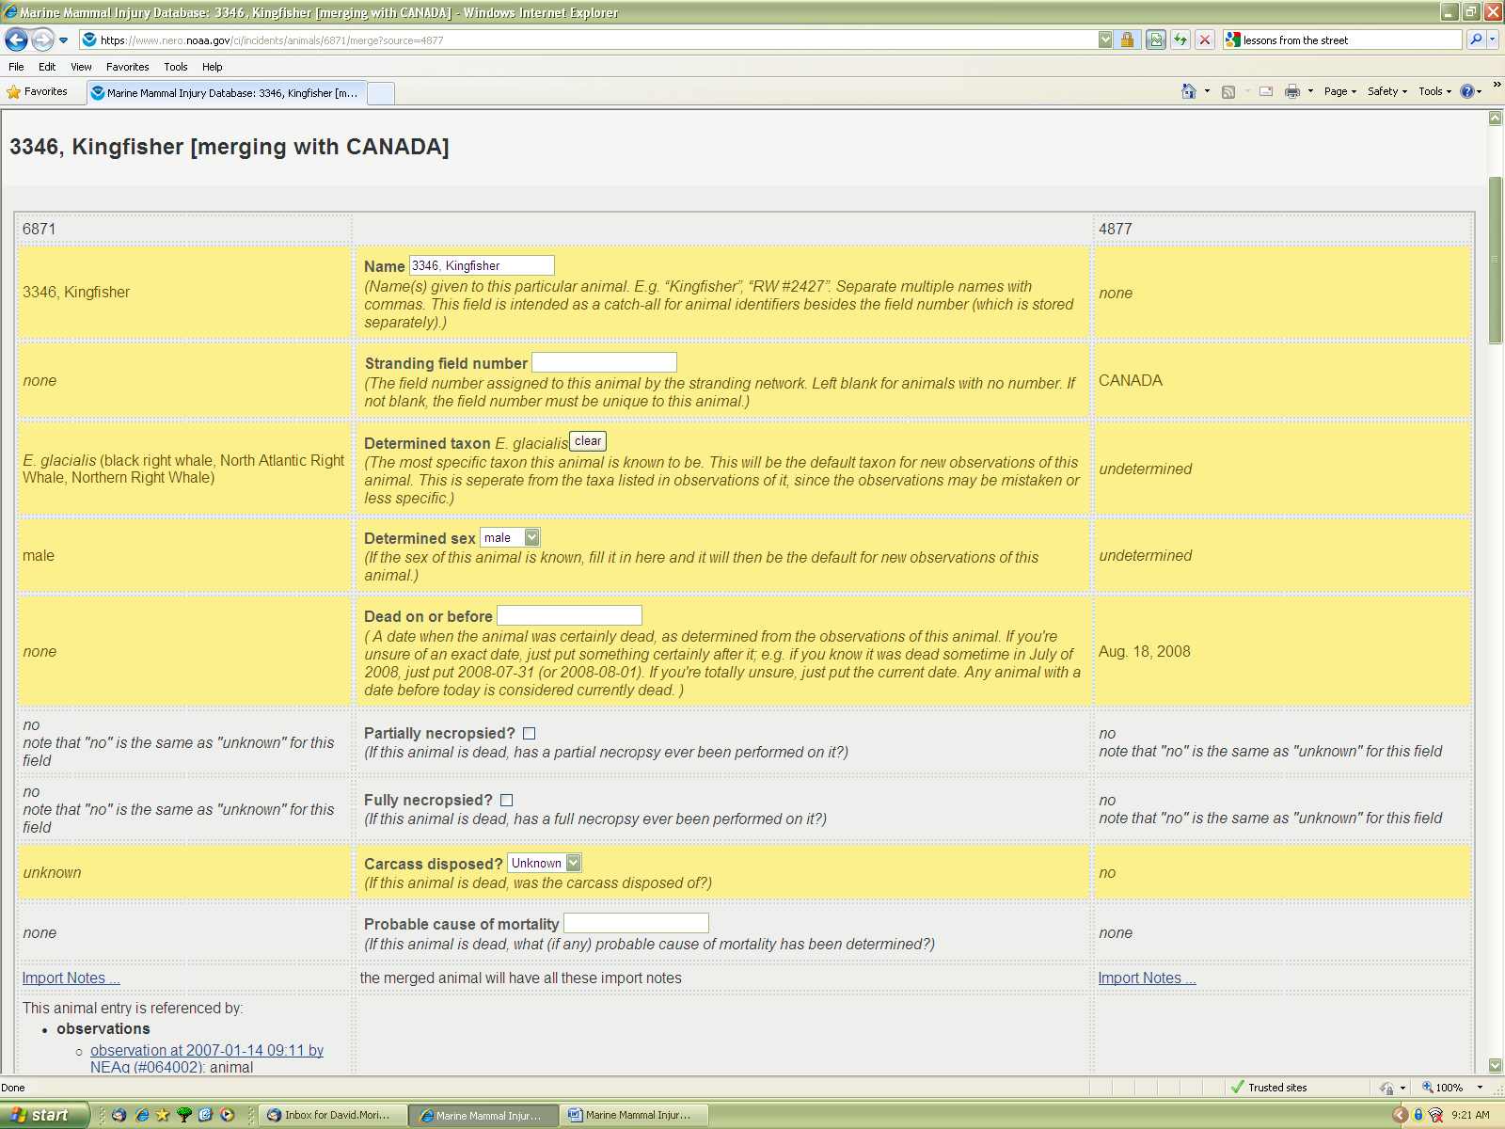

This merging page is similar for cases and observations. It is important to remember that if you edit the central column, that is the final field entry for that animal/case/observation.